Interior design has evolved significantly in recent years, being influenced by the combination of technological advancements, globalisation, and a growing emphasis on sustainability. This transformation has not only expanded the market for interior design, but has also led to the integration of art and technology, customisation, and collaboration of various disciplines. In this article, we’ll explore how these key factors have shaped the contemporary landscape of interior design.

## Technological Advancements

The emergence of advanced technologies, such as 3D printing, virtual reality (VR), augmented reality (AR) and artificial Intelligence (AI) has revolutionised the way Interior Designers conceptualise and execute their ideas. AI has also reverse engineered the creative process, by providing for design solutions which may have been missed in the traditional process of Design and Development. 3D printing enables designers to create bespoke furniture and fixtures, blurring the line between art and functionality. VR and AR allow clients to visualise designs in real-time, fostering better communication and understanding between designers and their clients. An example of technological advancements in the industry are the various platforms offered by Furniture Companies which utilise AR to allow users to virtually place furniture in their space before making a purchase, revolutionising the way customers interact with products and visualise their interiors.

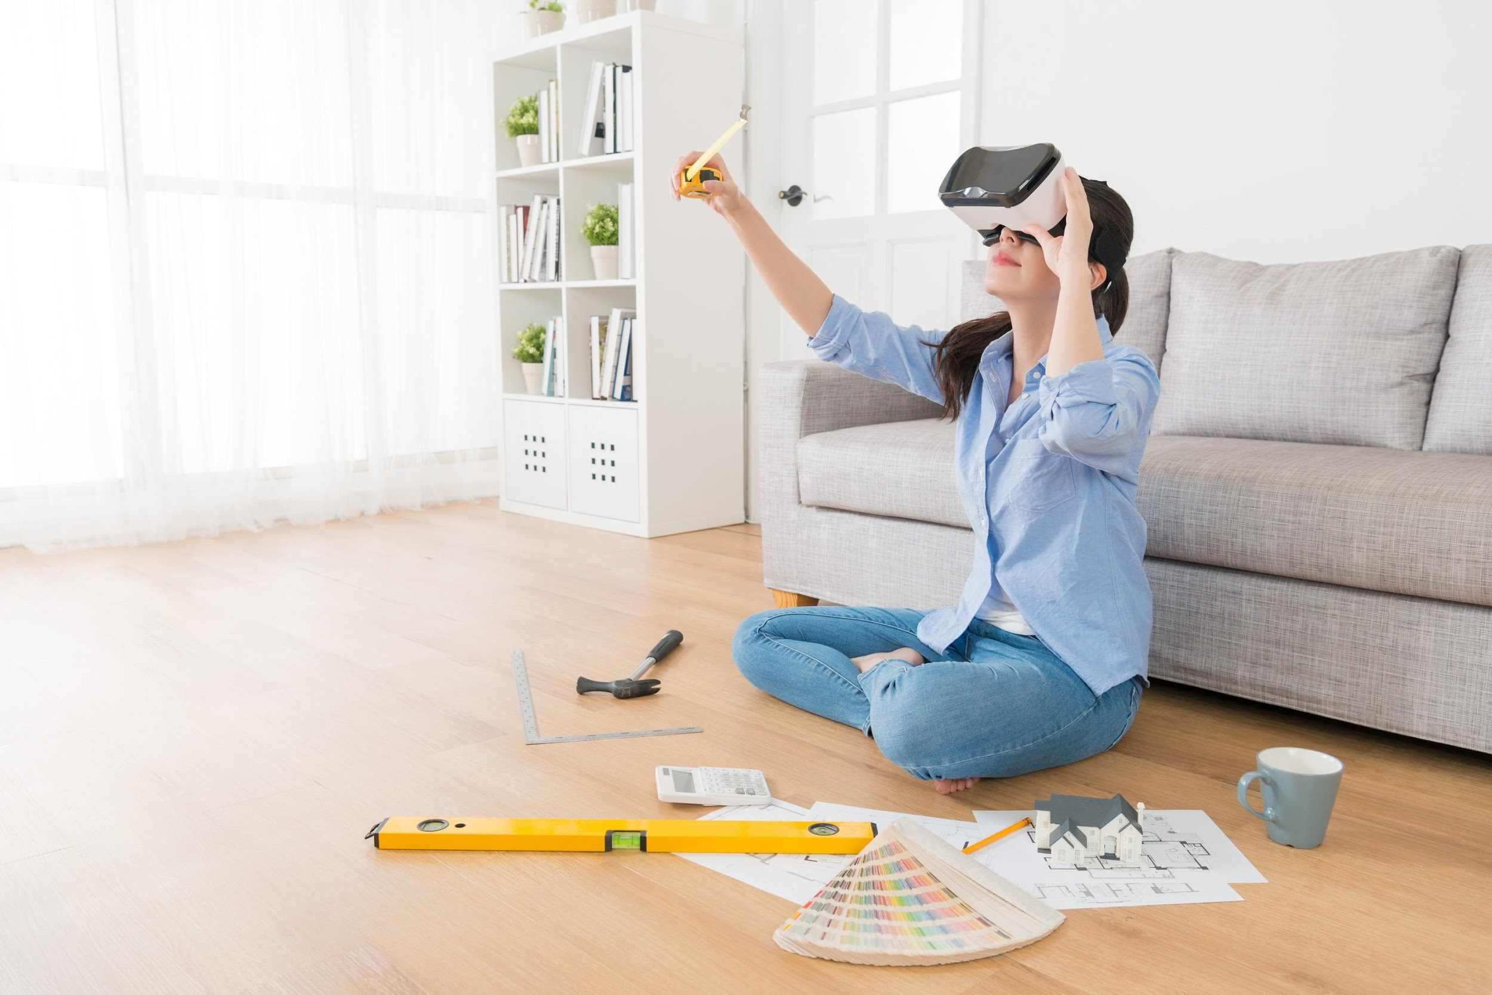

Fig 1. Canva (n.d.), An Interior Designer using VR

# 

## Globalisation and Market Expansion

With the world becoming increasingly interconnected, interior design has exceeded geographical boundaries. Designers can draw inspiration from various cultures and incorporate elements from around the globe into their work, in order to diversify their designs. Globalisation has also led to the expansion of the market, with design trends and products reaching a wider audience than ever before. Lastly, it has allowed for designers to practise their work beyond the boundaries of their physical location. A typical example is the global rise of the Scandinavian influence in Interior Design. Characterised by minimalist aesthetics and functional design principles, it has pushed geographical boundaries and has become a global trend.

## Sustainability and Eco-Friendly Design

In response to growing environmental concerns, there has been a significant shift towards sustainable and eco-friendly design practices. Designers are incorporating renewable materials, energy-efficient systems, and biophilic design principles into their projects. Sustainable design is not only a trend, but a fundamental ethos which is driving the future of interior design. The Bullitt Center in Seattle stands as a pioneering example, showcasing net-zero energy usage, rainwater harvesting, and composting toilets, setting a new standard for sustainable building practices and inspiring more eco-conscious interior design.

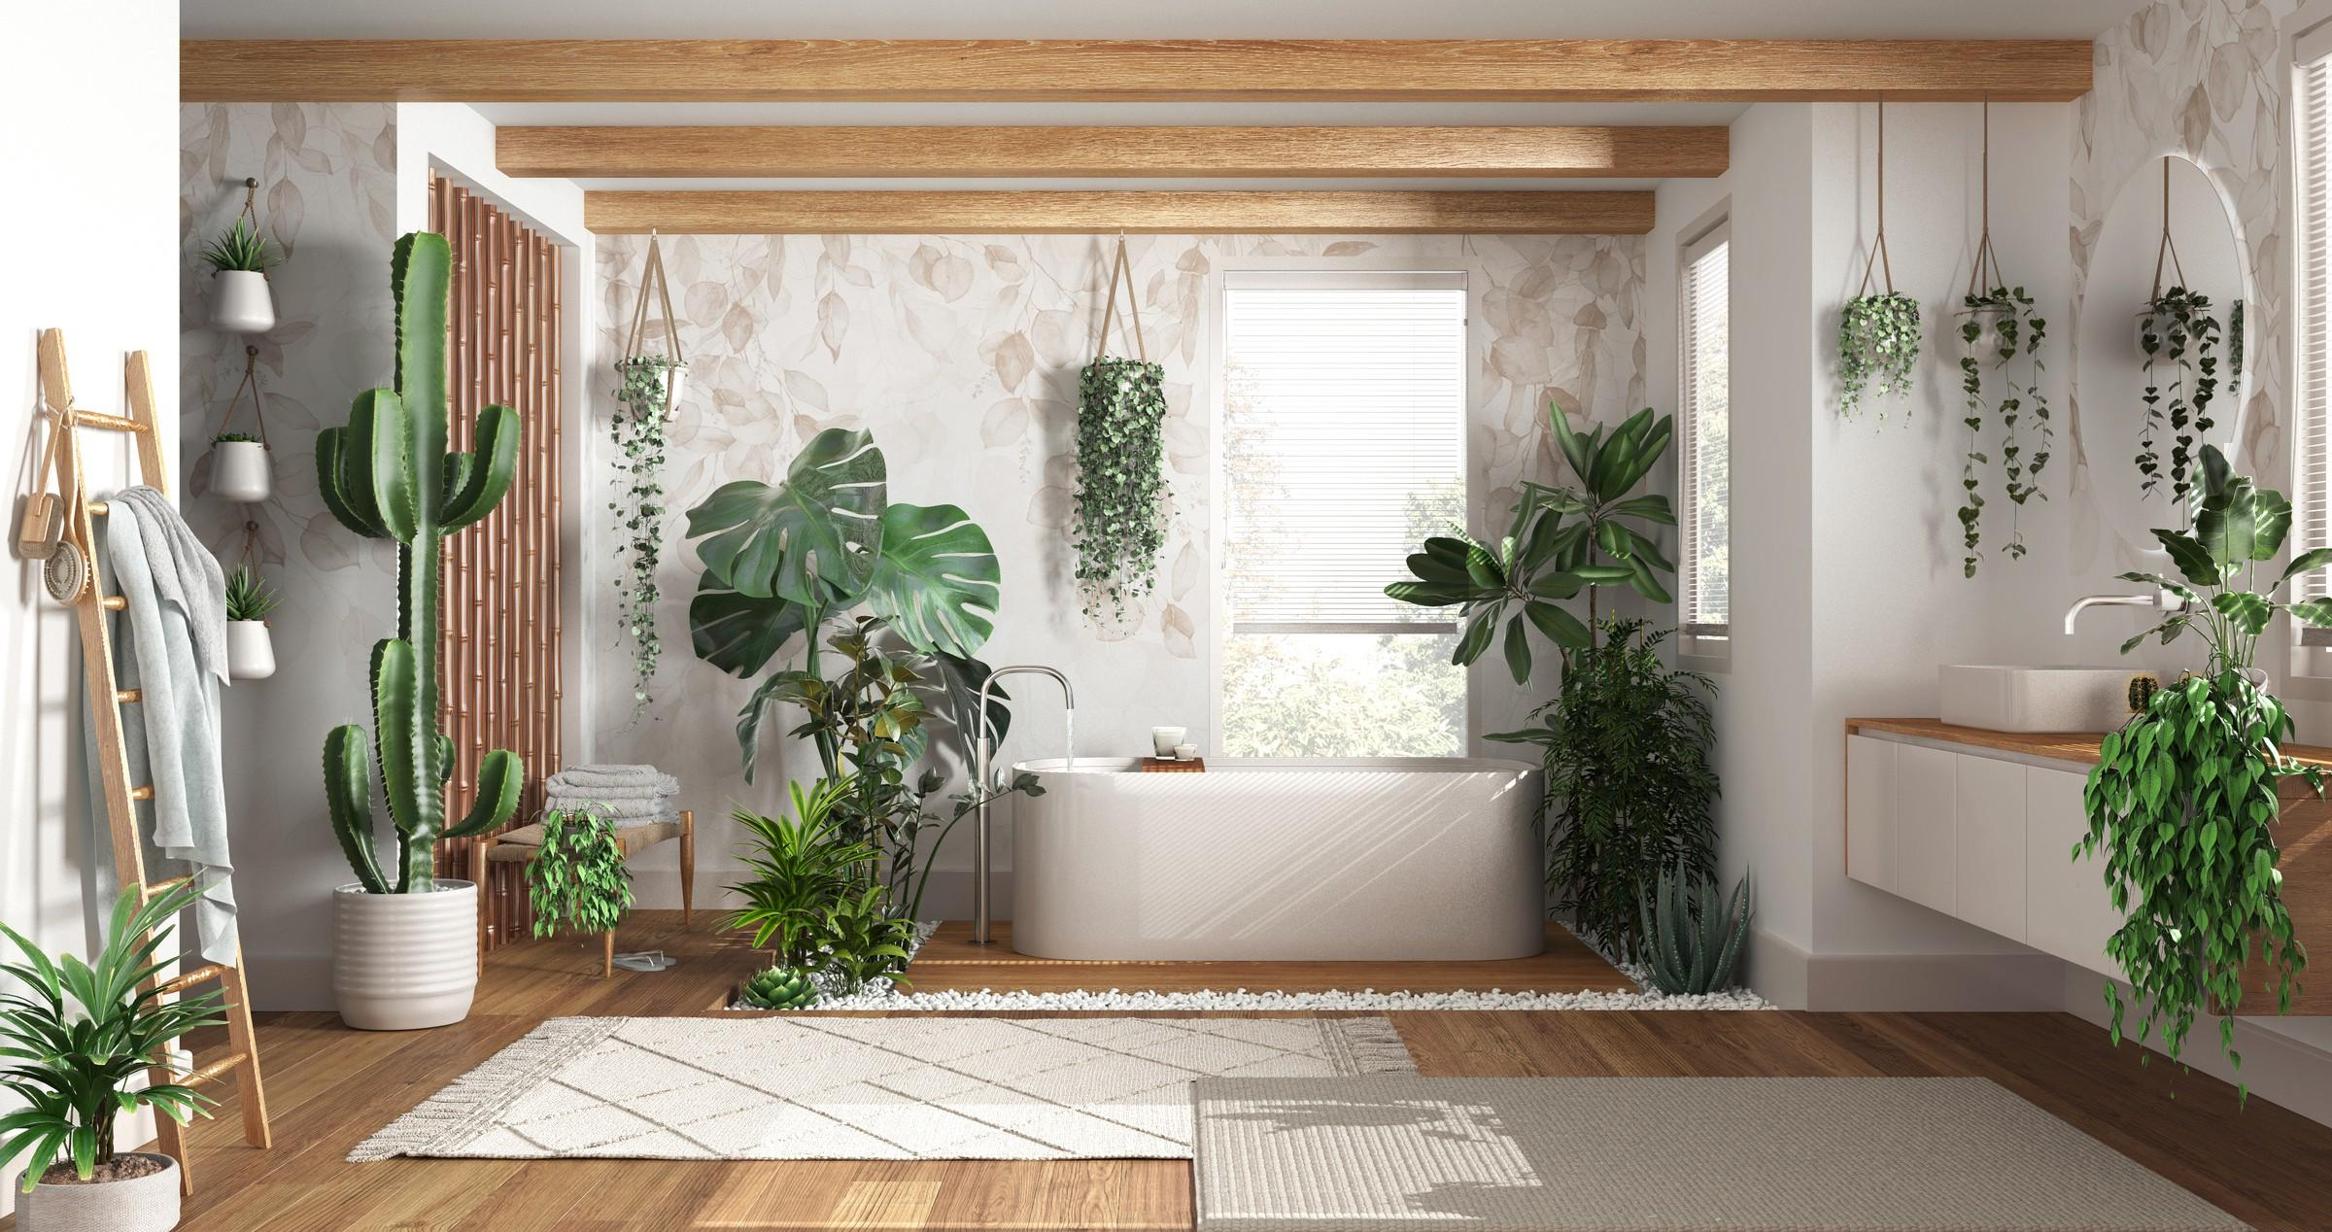

Fig 2. Canva (n.d.), Biophilic Interior

## Integration of Art and Technology

The marriage between art and technology in interior design is more prevalent than ever before. From interactive installations, to digital art displays, technology is being seamlessly integrated into interior spaces. This is creating immersive and engaging experiences for the users of the spaces. This fusion of art and technology allows designers to push the boundaries of creativity and innovation. The "[Digital Water Pavilion](https://archello.com/project/digital-water-pavilion)" in Spain is a great example of this fusion. It features a dynamic water curtain which is controlled by digital sensors, transforming the architecture into an interactive art installation that engages visitors on multiple sensory levels.

## Customisation and Personalisation

The rise of digital platforms and advanced manufacturing techniques, have contributed in customisation and personalisation to become key trends in Interior Design. Clients are seeking unique, one-of-a-kind spaces, material finishes and even furniture that reflect their individuality and lifestyle. Designers are utilising technology to offer bespoke solutions, from customised furniture pieces to personalised colour palettes that cater to the diverse needs and preferences of their clients. For example, renowned furniture companies now offer customisable furniture options, empowering customers to tailor designs to their specific preferences and spatial constraints, thereby fostering a sense of ownership and individuality in their interiors.

## 

## Online Platforms and Digital Marketplaces

The digital revolution has transformed the way in which interior design services are accessed and delivered. Online platforms and digital marketplaces connect clients with designers, allowing for greater accessibility and convenience. Designers can showcase their portfolios, collaborate with clients remotely, and with just a few clicks, source products from around the world, facilitating a more streamlined and efficient design process. Platforms like Pinterest , for example, serve as virtual design hubs, where users can distil inspiration, connect with professionals, and source furnishings, effectively bridging the gap between virtual inspiration and real-world implementation.

## Collaboration and Interdisciplinary Approaches

Collaboration and interdisciplinary approaches are becoming increasingly prevalent in the field of interior design. Designers are collaborating with architects, engineers, artists, and craftspeople to bring diverse perspectives and expertise to their projects. This interdisciplinary approach promotes innovation and creativity, leading to the development of holistic and integrated design solutions that address the complex needs of modern society. The "TWA Hotel" project at JFK Airport is an example of successful collaborative design, with architects, interior designers, and historians collaborating to revive the iconic TWA Flight Centre into a vibrant hotel space that seamlessly marries mid-century modern aesthetics with contemporary functionality.

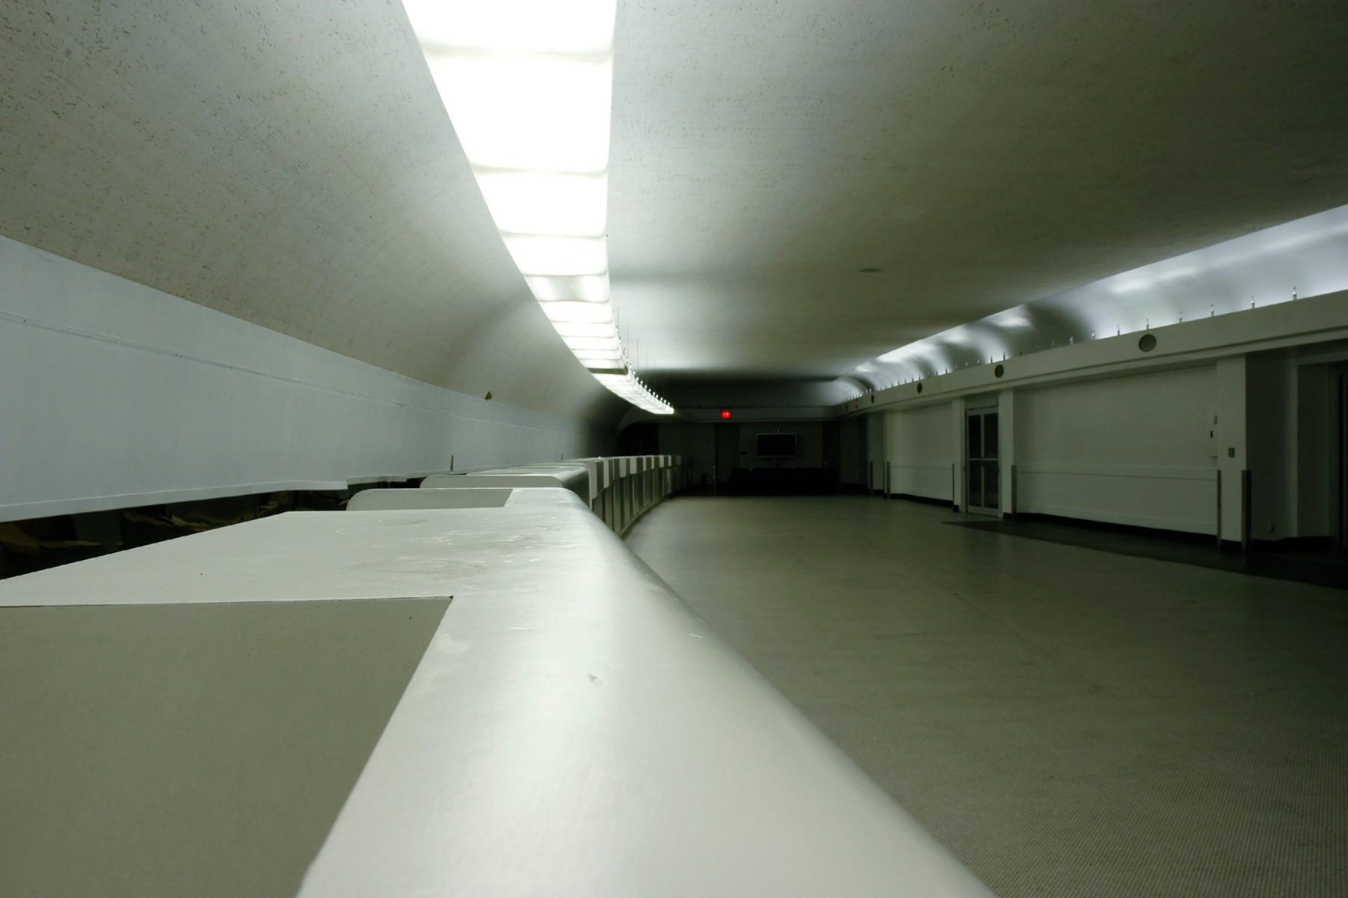

Fig 4. Canva (n.d.), Old TWA Terminal

The evolution of interior design is testament to the dynamic interplay between tradition and innovation, technology and sustainability, global influences, and personalised experiences. As designers continue to push the boundaries of creativity and functionality, the future of interior design promises to be a captivating blend of artistry, technology, and conscientious design practices, enriching our lived experiences in profound ways.